Elastic Pool Creation

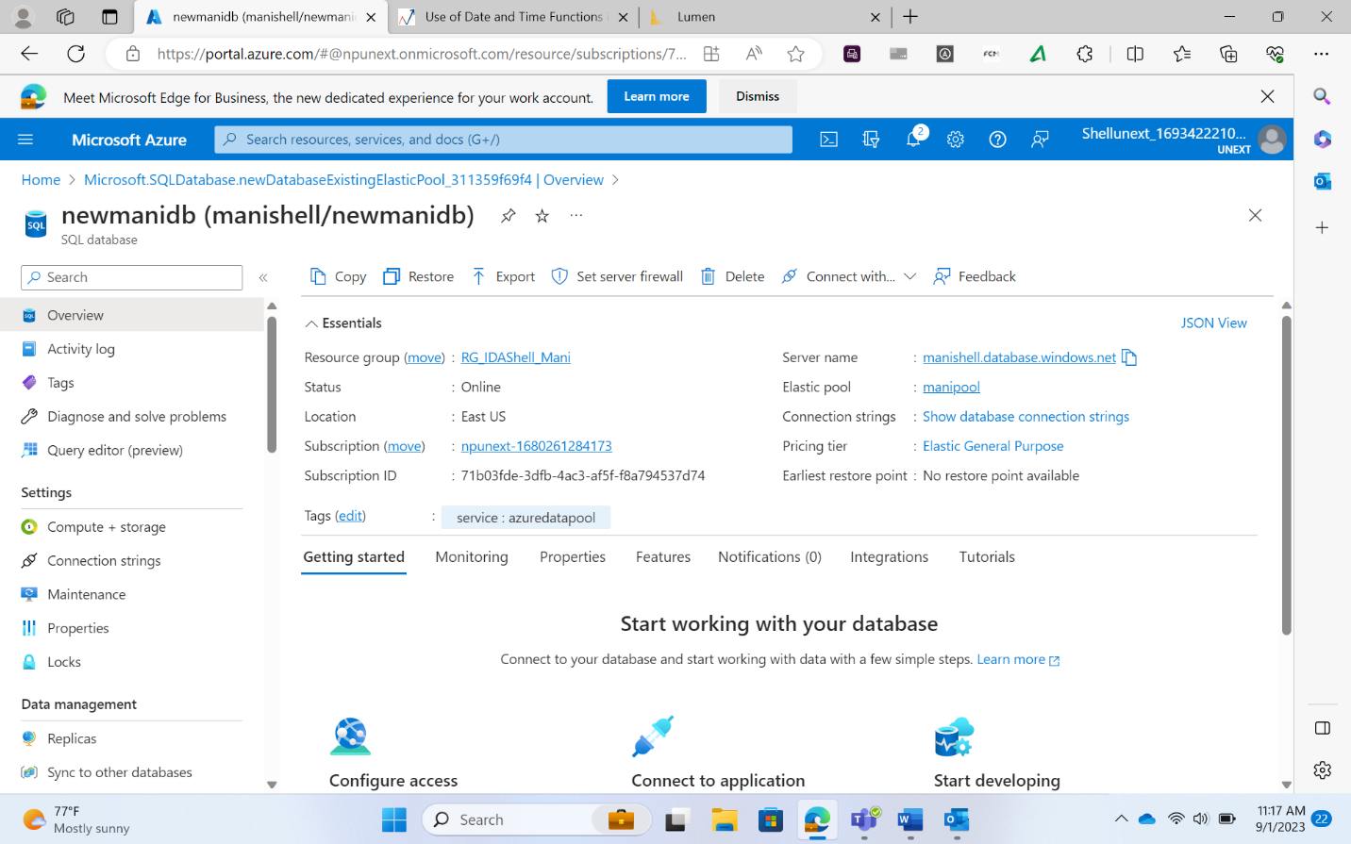

Firewall Issues

* If there are firewall issues which do not permit connection to the Azure SQL Database, then, inside the server, go to networking, then add the network’s IP address at the bottom of the page to ensure that the database is connected

Join Operation

* Inner Join

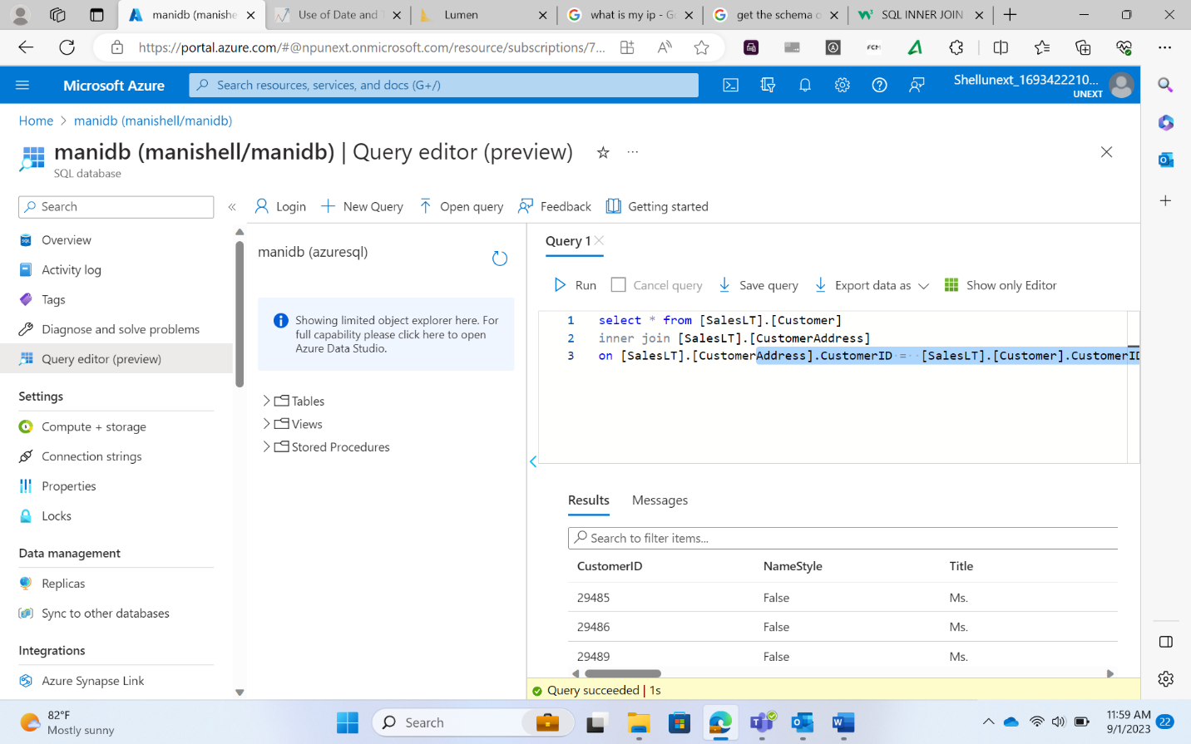

* Left Join

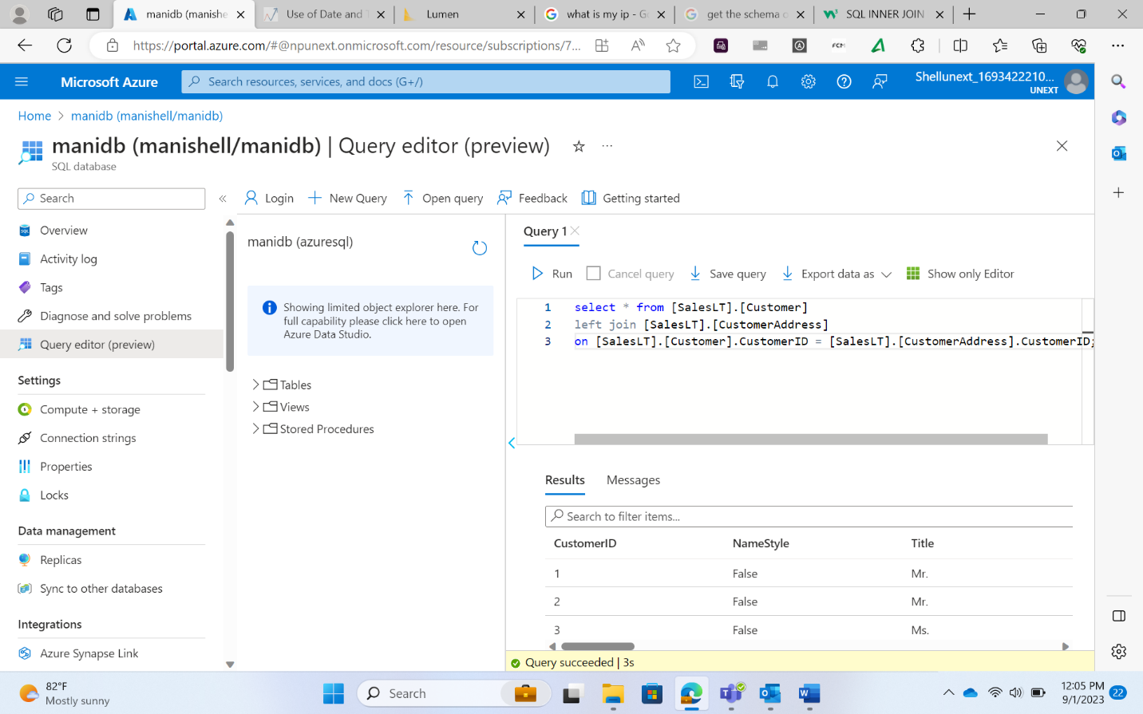

* Right Join

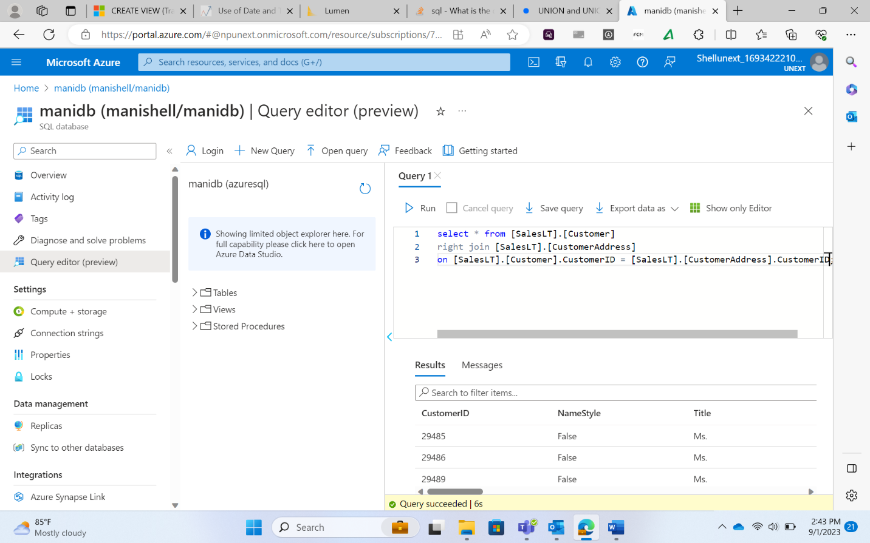

Stored Procedures

* Stored procedures are programs that can perform multiple operations, such as inserting, updating, deleting, or selecting data.
* Several queries can be executed consecutively
* Use of parameters make it very useful
* Begin and End are used here
* The queries can be optimized

Views

* Views are similar to stored procedures

CREATE VIEW cus

AS

  SELECT A.CustomerID, B.AddressID

  FROM [SalesLT].[Customer] A LEFT JOIN [SalesLT].[CustomerAddress] B ON A.CustomerID = b.CustomerID

GO;

* Use of Go in the view creation query is optional
* It just acts as an end tag to mark the end of the query

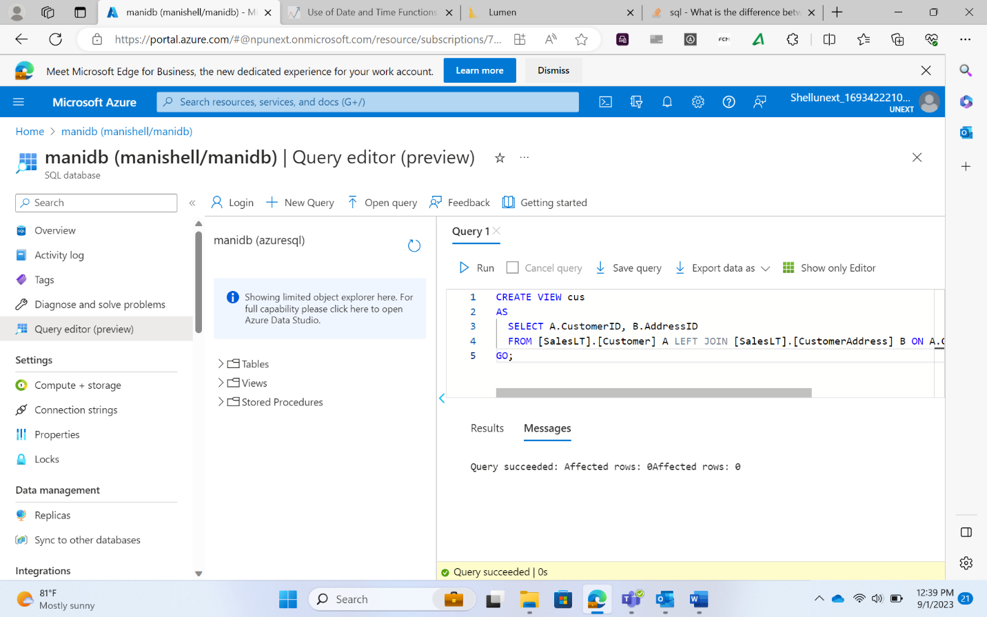

**A Stored Procedure:**

* Accepts parameters
* Can **NOT** be used as building block in a larger query
* Can contain several statements, loops, IF ELSE, etc.
* Can perform modifications to one or several tables
* Can NOT be used as the target of an INSERT, UPDATE or DELETE statement.

**A View:**

* Does **NOT** accept parameters
* Can be used as building block in a larger query
* Can contain only one single SELECT query
* Can **NOT** perform modifications to any table
* But can (sometimes) be used as the target of an INSERT, UPDATE or DELETE statement.

Stored Procedure

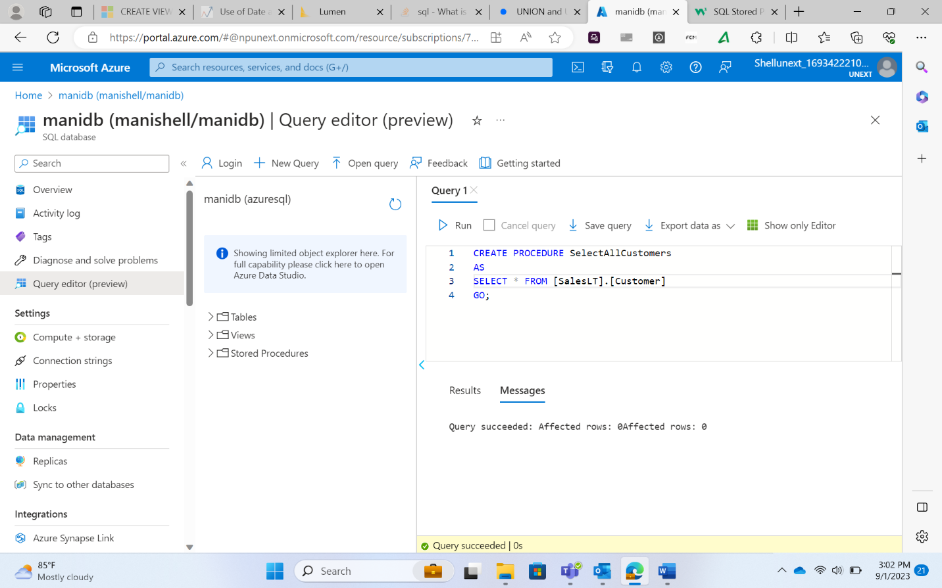

Union

* UNION removes duplicates from our query results

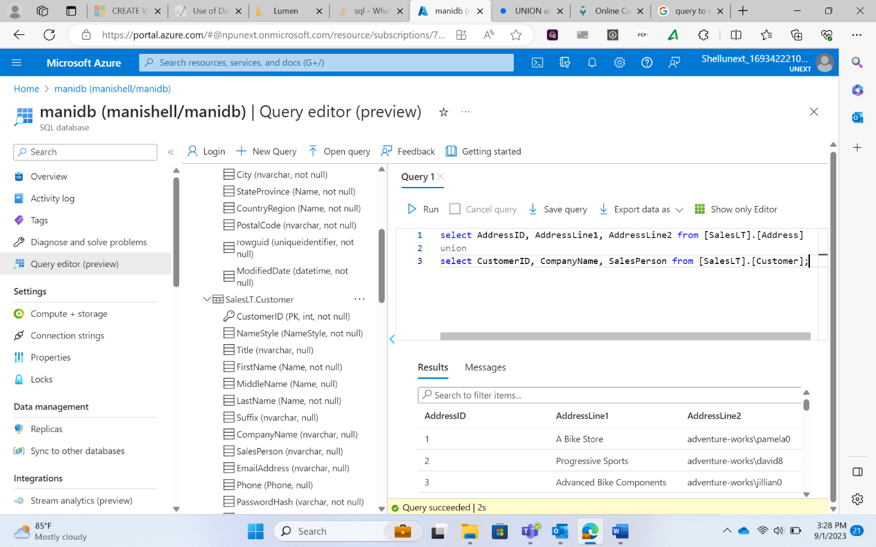

Union All

* UNION removes duplicates from our query results

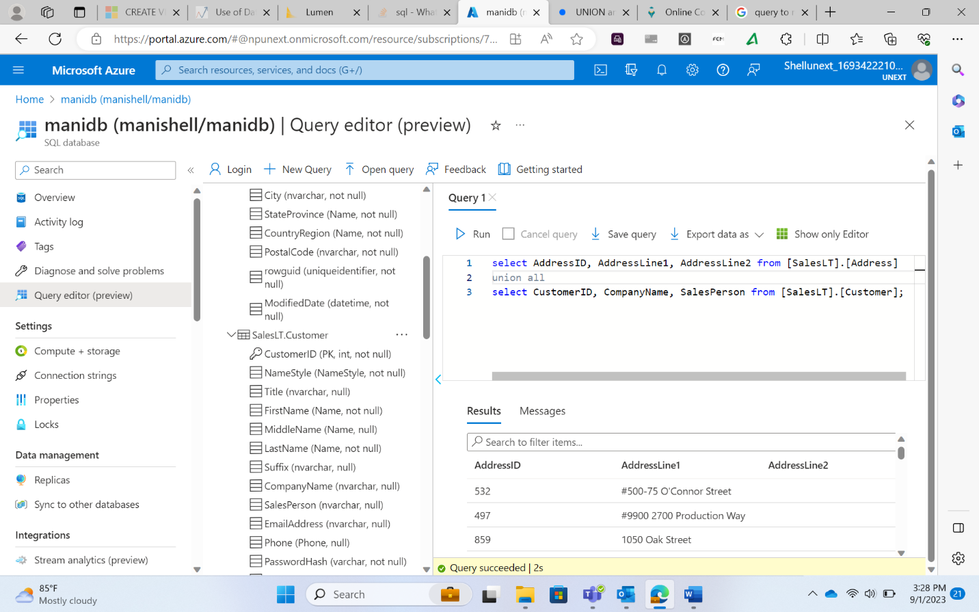

Intersection

* Only the common data is retrieved

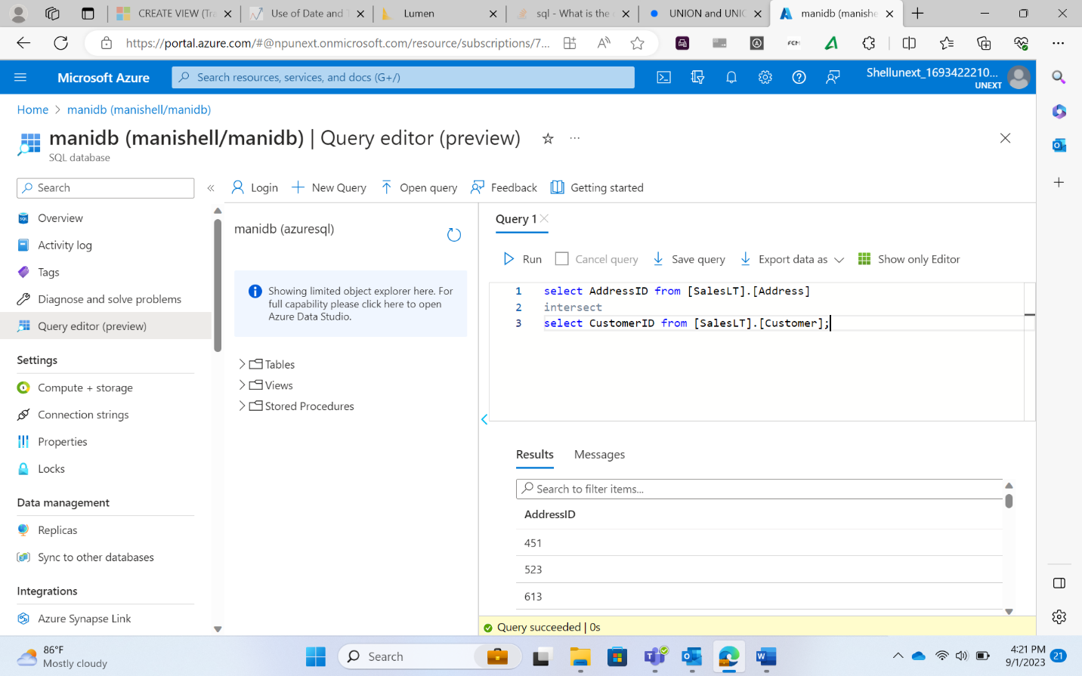

Index

* Clustered index
  + Only used for primary key
  + Orders and creates clusters
  + Each cluster is assigned indices
  + Using theses indices records are retrieved

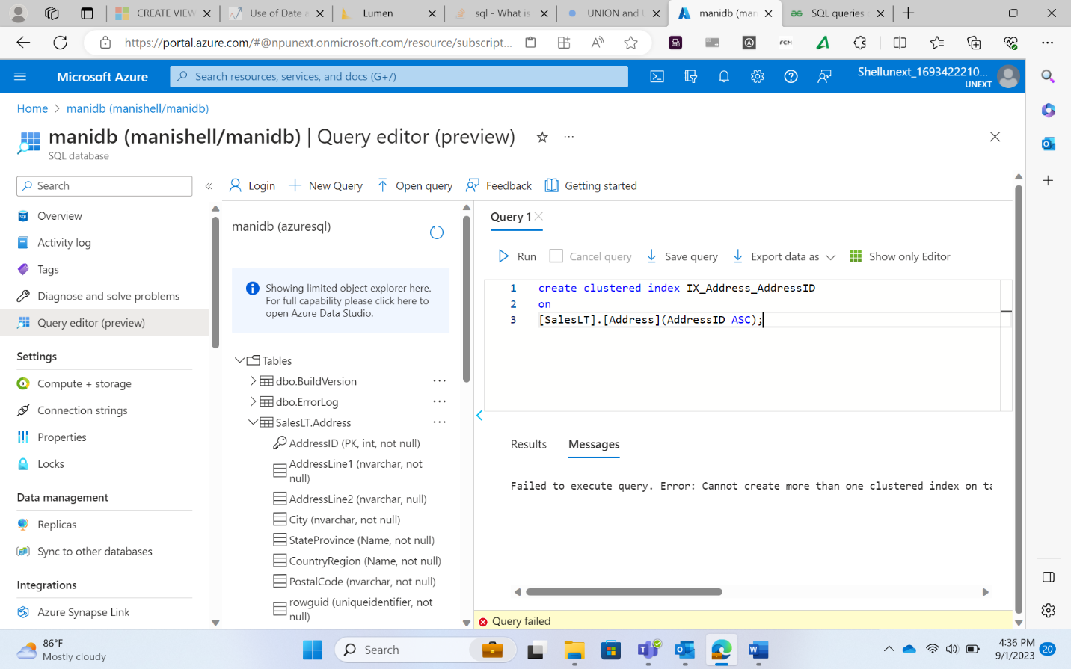

* Non-clustered index
  + The process is almost the same as above
  + The only difference is that the data is not ordered before clustering
  + After the cluster is created on the original data itself, indexing is done and records are retrieved

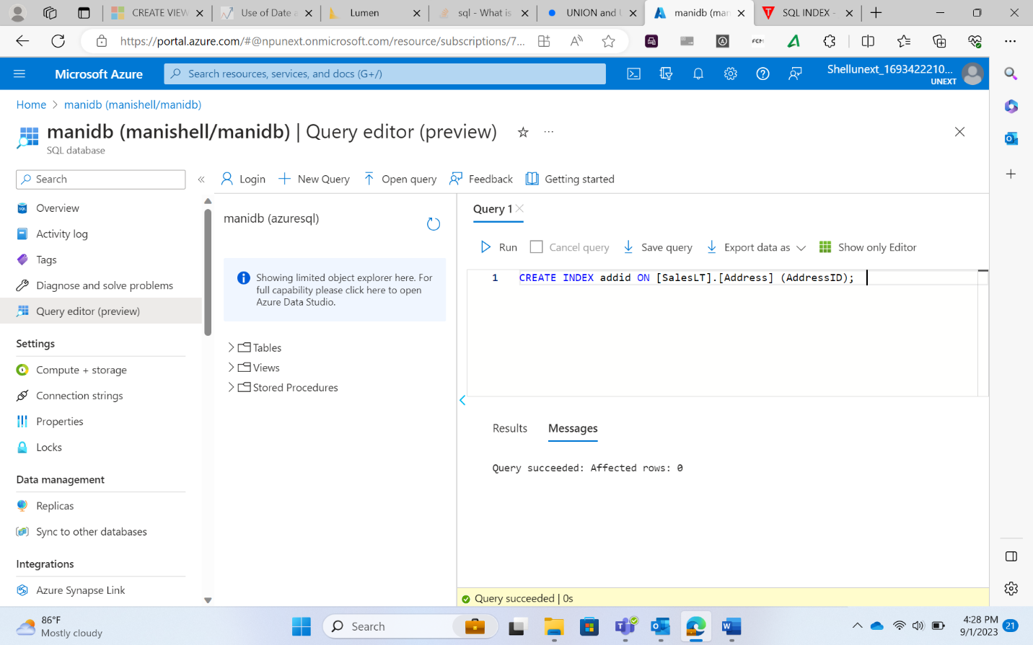

Common Table Expression

* Used for huge amounts of data